CS 305 Project One Template

Document Revision History

Version | Date | Author | Comments
1.0 | 11/11/25 | Amy Marquis | First Draft

Client



Instructions
Submit this completed vulnerability assessment report. Replace the bracketed text with the relevant information. In this report, identify your security vulnerability findings and recommend the next steps to remedy the issues you have found.

- Respond to the five steps outlined below and include your findings.
- Respond using your own words. You may also include images or supporting materials. If you include them, make certain to insert them in the relevant locations in the document.
- Refer to the Project One Guidelines and Rubric for more detailed instructions about each section of the template.

Developer
Amy Marquis

1. Interpreting Client Needs
Determine your client’s needs and potential threats and attacks associated with the company’s application and software security requirements. Consider the following questions regarding how companies protect against external threats based on the scenario information:

- What is the value of secure communications to the company?
- Are there any international transactions that the company produces?
- Are there governmental restrictions on secure communications to consider?
- What external threats might be present now and in the immediate future?
- What modernization requirements must be considered, such as the role of open-source libraries and evolving web application technologies?

As a financial services company, Artemis prioritizes security to protect customers' assets and privacy from targeted cyberattacks. Engaging in international transfers exposes the company to various foreign laws concerning Personally Identifiable Information (PII), record retention, and secure communications.

In the United States, laws such as the Electronic Communications Privacy Act and the Computer Fraud and Abuse Act underscore the need for compliance, making it advisable to seek outside legal counsel. The company's online presence increases the risk of cybercrimes ranging from minor annoyances to severe threats, including denial-of-service attacks and data breaches, which can result in financial losses and damage to reputation.

Artemis must also be cautious when using open-source code. Licenses like the GNU General Public License could require shared modifications, complicating the protection of proprietary software. Furthermore, vulnerabilities in open-source components can have serious consequences, as demonstrated by the Log4J incident, which impacted millions of systems. Regular updates to all software libraries are essential for safeguarding against evolving threats and maintaining security.

2. Areas of Security
Refer to the vulnerability assessment process flow diagram. Identify which areas of security apply to Artemis Financial’s software application. Justify your reasoning for why each area is relevant to the software application.

In a RESTful API, it’s important to focus on Input Validation, Secure API Interactions, Error Handling, and Encapsulation.

Input Validation helps “sanitize” user inputs, preventing issues even from trusted users. Securing the API builds trust in connections. While Spring provides some error checking, generic handling is needed to protect code structure from potential hackers. Sensitive data should be encapsulated with private variables and Get/Set functions.

Cryptography is vital, emphasizing RSA-2048 encryption for data flow and compliance with local encryption laws.

3. Manual Review
Continue working through the vulnerability assessment process flow diagram. Identify all vulnerabilities in the code base by manually inspecting the code.

The `Customer` class currently exposes the `account_balance` as a public attribute, which is a security risk. This should be changed to private, with better and setter methods to control access and manipulation.

In the `MyDateTime` class, methods like `setMyDateTime` are poorly coded and incomplete. These methods require refactoring to ensure they are functional and maintainable.

The `DocData` class hardcodes readable usernames and passwords, which is a significant security issue. These should be obfuscated and more complex than simple combinations like “root.” Additionally, all passwords must be properly salted and hashed to enhance security.

Error checking across the application is inadequate, with only a few methods implementing it. `Artemis` should adopt robust error-handling practices. Error messages must be generic to avoid revealing sensitive information, such as returning a detailed stack trace during SQL connection failures in the `read_document` method. This will help protect the system from potential exploits.

4. Static Testing
Run a dependency check on Artemis Financial’s software application to identify all security vulnerabilities in the code. Record the output from the dependency-check report. Include the following items:

- The names or vulnerability codes of the known vulnerabilities
- A brief description and recommended solutions provided by the dependency-check report
- Any attribution that documents how this vulnerability has been identified or documented previously

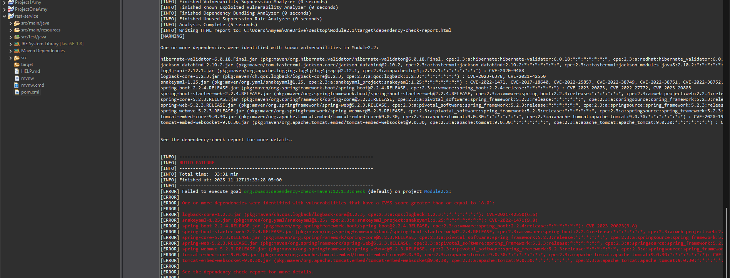

5. Mitigation Plan
Interpret the results from the manual review and static testing report. Then identify the steps to mitigate the identified security vulnerabilities for Artemis Financial’s software application.

To begin with, it’s important to update all dependent libraries to their latest stable versions. This ensures security and compatibility, as outdated libraries can introduce vulnerabilities. Developers may need to modify existing code to align with these library updates.

After updating, the team should recompile the entire codebase to identify any syntax or functional errors. It's essential for the code to pass all internal tests to ensure proper functionality. Developers should carefully monitor warnings and errors during this phase.

Once the code compiles successfully and passes tests, the next step is refactoring to implement clear, user-friendly error messages. This enhances user experience and security by safeguarding sensitive information. Additionally, strong input validation and sanitization must be enforced to protect against threats like SQL injection and XSS attacks, along with implementing salting and hashing for password storage.

